Solving problems using array functions on rest countries data.
- Get all the countries from Asia continent /region using Filter function

Code:
const url = "https://restcountries.com/v3.1/all";
const countryname = document.getElementById("container");
addEventListener("DOMContentLoaded",getAsianCountries);
function getAsianCountries() {
fetch(url).then((response) =>{
response.json().then((data) =>{
data.filter((country)=>{
if(country.region=="Asia"){
// console.log(country.name.common)
countryname.innerHTML += `
<table>
<tr>
<td>${country.name.common}</td>
<tr>
</table>
`
}
})
})
})
}

Output:
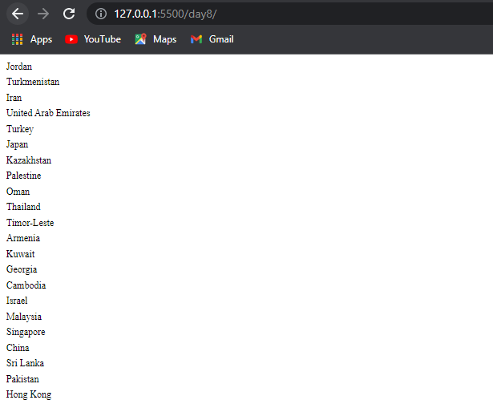
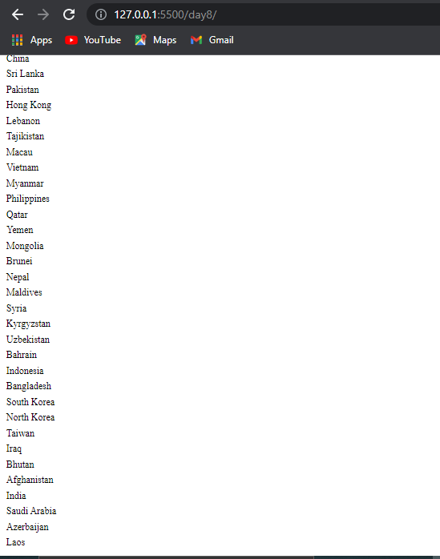

- Get all the countries with a population of less than 2 lakhs using Filter function

Code:
const url = "https://restcountries.com/v3.1/all";
const countryname = document.getElementById("container");
addEventListener("DOMContentLoaded",getCountries);
function getCountries() {
fetch(url).then((response) =>{
response.json().then((data) =>{
data.filter((country)=>{
if(country.population <= 200000){
countryname.innerHTML += `
<table>
<tr>
<td>Country: ${country.name.common},</td>
<td>Population:${country.population}</td>
<tr>
</table>
`
}
})
})
})
}

Output:
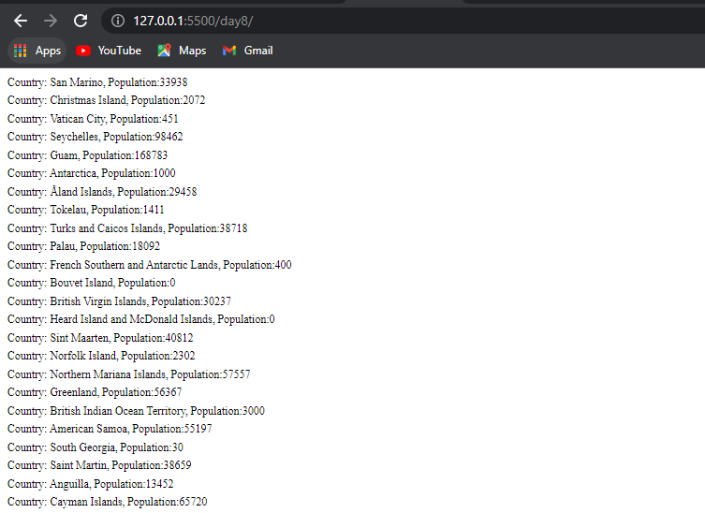

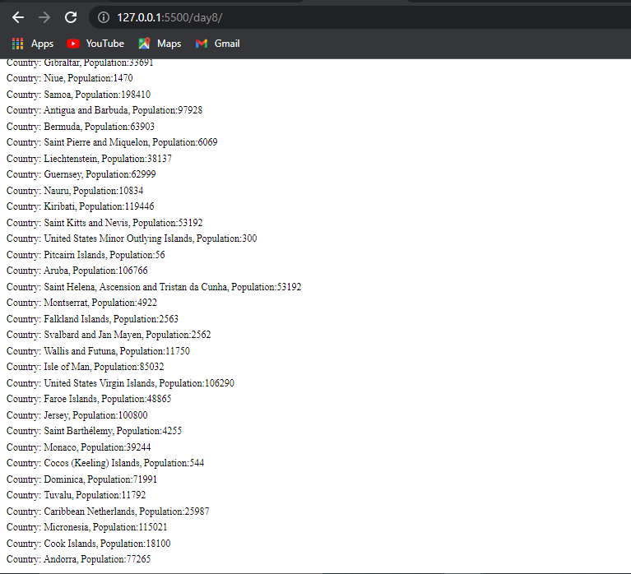

- Print the following details name, capital, flag using forEach function

Code:
const url = "https://restcountries.com/v3.1/all";
const countryname = document.getElementById("container");
addEventListener("DOMContentLoaded",getCountries);
function getCountries() {
fetch(url).then((response) =>{
response.json().then((data) =>{
data.forEach((country)=>{
countryname.innerHTML += `
<table>
<tr>
<td>Country: ${country.name.common}</td>
<td>Capital:${country.capital}</td>
<td><img src="${country.flags.png}"/></td>

<tr>
</table>
`
})
})
})
}

Output:

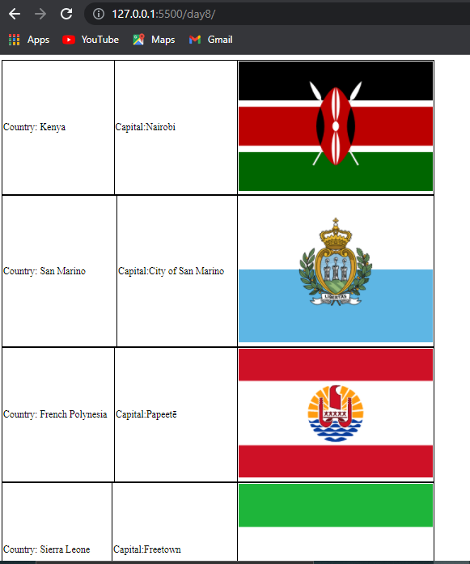
- Print the total population of countries using reduce function

Code:

const url = "https://restcountries.com/v3.1/all";
var totalPopulations;
const countryname = document.getElementById("container");
addEventListener("DOMContentLoaded",getCountries);
function getCountries() {
fetch(url).then((response) =>{
response.json().then((data) =>{
totalPopulations = data.reduce(function(result,item){
return result+item.population;
},0);
console.log("Total population of countries is:"+totalPopulations);
})
})
}

Output:

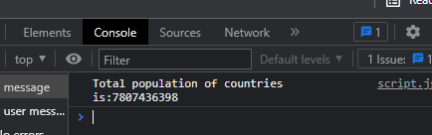

- Print the country which uses US Dollars as currency.
Code:
const url = "https://restcountries.com/v3.1/all";
const countryname = document.getElementById("container");
addEventListener("DOMContentLoaded",getAsianCountries);
function getAsianCountries() {
fetch(url).then((response) =>{
response.json().then((data) =>{
for(let country of data)
{
if(country.currencies)
{
let curr=country.currencies;
if(curr.USD)
{
console.log(country.name.common);
console.log(country.currencies);
}

}
}
})
})
}

Output:

